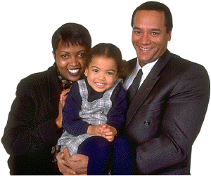
PERSONAL INFORMATION

First Person
Last Name |  | First Name
Social Security Benefit: Will you be eligible for the maximum benefit? | Birth Date mm/dd/yyyy | Plan until maximum age of? (Life Expectancy)
At what age do you want to retire?
Social Security Number (optional)
Occupation | Employer
Email address

Inflation Rate (CPI) % | Percent for increase of Social Security Benefits? %

Second Person
Last Name |  | First Name
Social Security Benefit: Will you be eligible for the maximum benefit? | Birth Date mm/dd/yyyy | Plan until maximum age of? (Life Expectancy)
At What Age Do You Want To Retire?
Social Security Number (optional)
Occupation | Employer
Email address

Comments:
Contact Information

Home Address |  | # of Years?
 |  | Phone
City | State | Zip
First Person’s Additional Contact Information
Cell phone |  | Fax
Secondary email address
Employer address |  | Phone
City | State | Zip
Employer website
Second Person’s Additional Contact Information
Cell phone |  | Fax
Secondary email address
Address |  | Phone
City | State | Zip
Employer website
Other Address
Address |  | Phone
City | State | Zip


Other Advisors You Want Us to Know About

Name of Accountant
Address |  | Phone
City | State | Zip
Name of Attorney
Address |  | Phone
City | State | Zip
Name of Other Advisor
Address |  | Phone
City | State | Zip

Comments:

